IP Protection in the Fashion Industry in China
The fashion industry encompasses the design, manufacturing, distribution, retailing, marketing and promotion of clothing, footwear and accessories and is worth billions of Euros every year.
While the fashion industry initially developed in Europe and the United States (the Italian footwear industry is one of the largest in the world and the textile industry is one of the United States’ most important employers in the manufacturing sector), today, fashion is an international and highly globalized sector.
China’s fashion industry, for instance, is set to become the world’s second largest fashion market by 2020, with sales expected to reach over RMB 1.3 trillion (EUR 182 billion) – roughly three times their current level. According to the Boston Consulting Group, China will account for 30% of the global fashion market’s growth over the next five years.
China therefore represents both opportunities as a manufacturing hub and a maturing consumer market, and risks, as a potential source of counterfeit merchandise. In order to avoid potentially damaging losses, EU SMEs operating in the fashion industry should take important measures to protect their intellectual property rights (IPR) in China.
Trade marks
Trade marks associated with fashion and design brands are the most important type of intellectual property that EU SMEs should protect in this industry. A trade mark is a distinctive sign that identifies the goods of a producer or designer, allowing one good or brand to be distinguished from another. Brand recognition and reputation allow companies to position themselves in international markets. In addition to brands, distinctive fabric designs may also be protected as a trade mark if they have become distinctive through long use. While instances are relatively rare, examples such as the Burberry check design (which has been granted trade mark protection in China) demonstrate its possibility.
The value of a brand as an intangible asset of a company is occasionally taken for granted and given inadequate attention in the business cycle. In order to protect your brand in China, you should take immediate action to register your trade mark before conducting any business. This is because European IPR will not protect you in the Chinese market.
Since China operates the ‘first-to-file’ principle, where the right to a trade mark is granted to the first person who applies for that trade mark, forgetting to register can be potentially dangerous. If your trade mark is registered by someone else in China before you have registered it (i.e. if a Chinese company files the trade mark belonging to an EU company before the EU company files), it can be virtually impossible to reclaim your trade mark unless you can prove that there is a relationship between your company and the company that registered the trade mark.
Furthermore, registering a trade mark in Chinese is important for several reasons. Firstly, because foreign brands or company names are often difficult to pronounce – or carry different meanings – in Chinese. If a company fails to provide its own Chinese name or trade mark, Chinese consumers will choose their own (for example, due to their logo, Ralph Lauren is known as ‘three legged horse’ in China). Secondly, in a country where each character holds its own distinctive meaning, the characters used in a foreign branded trade mark, along with the sound, tone and look of Chinese characters, can significantly impact a brand’s reputation. There are three main options for companies wishing to choose a Chinese brand name.
These include:
- Creating a literal translation of a brand’s name into Chinese (as Apple Computers did with their Chinese name ‘Ping Guo’ (苹果) – literally the Chinese word for ‘apple’);
- Creating a phonetic translation (as with Siemens’ ‘Xi Men Zi’ (西门子)); and
- Combining a literal and a phonetic translation (the tactic used by Coca-Cola: ‘‘Ke Kou Ke Le’ (可口可乐), which means ‘taste and be happy’).
Trade mark registrations in China are inexpensive. The basic application fee is RMB 800; together with agent/legal fees, trade marks can generally be generated for around EUR 500-700. These costs are especially low when compared to the potential losses of forgetting to register your trade mark in China.
Design patents
Design patent protection is also extremely relevant to the fashion and design industry. Design patents can be sought for:
- The shape of a product;
- The pattern of a product;
- The shape and pattern of a product;
- The shape and colour of a product;
- The shape, pattern and colour of a product.
The colour alone cannot constitute the design of a product unless the change of colour can be regarded as a pattern.
The distinctive cut of fashion garments, the innovative shape of accessories like handbags (the Hermès ‘Birkin Bag’, for example), shoes (Dr. Martens) or the iconic style of a specific pattern on fabrics (Pringle’s argyle diamond pattern) are all examples of items that European SMES could protect with a specific design patent to maintain their competitiveness in the Chinese fashion market.
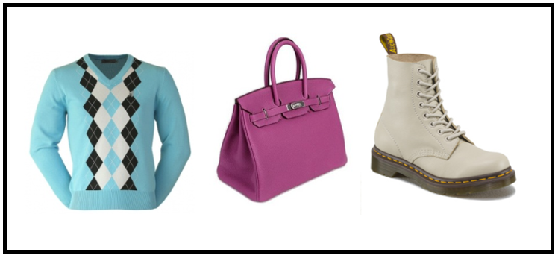
However, there are two main challenges facing this industry: 1) the rapid evolution of fashion; 2) the development of collections from year to year and the difference in design protection between Europe and China.
Europe and China differ in several aspects concerning the legal structures of design protection.
- Designs in China need to be registered as design patents in order to be protected – provisions of the Chinese Patent Law apple;
- In Europe protection is provided to both an Unregistered Community Design (UCD) and a Registered Community Design (RCD), which cover the whole EU. A UCD in Europe is often considered sufficient to protect fashion designs which have a short life span. If a longer term of protection is preferable, designs can be registered as RCDs with the Office for Harmonization in the Internal Market (OHIM). OHIM grants registration of RCSs within two working days. RCDs bestow exclusive rights on the holder and last for 25 years. In China, all designs have to be registered to be eligible for legal protection, which lasts 10 years.
- Patents must have absolute novelty in China; they must not have been disclosed anywhere in any capacity before they are registered, otherwise they are ineligible for protection.
Copyrights
European SMEs can also protect their IP through copyright. This should not substitute design patents as they are two kinds of intellectual property rights that protect two different things. However, copyright can be used as a standalone right or an added layer of protection in addition to a design patent.
Copyright is an automatic right that arises the moment a work is created – this means that once a work is created, in most cases, the creator will be granted protection in 164 member countries of the Berne Convention for the Protection of Literary and Artistic Works, including all EU countries and China.
However, voluntary copyright registration in China will provide proof of ownership, which can save you time and money in case of a dispute. Copyright can be registered any time, takes around 30 days, and is relatively inexpensive.

Distribution agents and franchising chains
Some European SMEs find it easier to appoint a Chinese distribution agent rather than to engage in direct sales or to establish their own company in China. In this case it is important to put an IP action plan in place that includes IP registrations in advance and signing written contracts with distributors and agents which include IP clauses. These contracts should clearly regulate the use and/or licensing terms of all related IPR as well as the marketing and promotional activities delegated to the distributor or agent.
Similarly, when investing in franchising stores in China, IPR will play a very important role in protecting your assets. It is therefore essential to regulate the obligations of both the franchisor and the franchisee with reference to the IP involved, such as trade mark registration and licensing, and copyright etc. It is recommended that advice is sought from lawyers – who can conduct due diligence – before implementing franchise operations in China.
Case study
This week, a Beijing court dismissed a trade mark case brought by US sports-champion Michael Jordan – arguably the world’s most popular international basketball player – against the Chinese company ‘Qiaodan Sports Co.’, for using a name and logo that he claimed was strikingly similar to his Nike-produced brand. Jordan is widely known in China by the Chinese transliteration ‘Qiaodan’, which sounds somewhat similar to his American surname.
According to Business Insider, Jordan appealed to the Chinese authorities in 2012 to revoke the trademark held by Qiaodan Sports Co., arguing that the Chinese company was misleading consumers by claiming that they were associated to the basketball star. In addition to the confusingly similar name, Qiaodian Sports Co. have also been branding their products with a logo of a jumping basketball player that resembles the logo used by Nike’s Air Jordan brand.
However, Chinese authorities refused Jordan’s request, as did a lower Beijing court and the Beijing Higher People’s Court, who made three claims:
- ‘Jordan’ is not the only reference for ‘Qiaodan’;
- ‘Jordan’ is a popular Western surname;
- The jumping basketball player logo did not possess any distinguishing features that could link it to Michael Jordan.
This case highlights the importance of registering a Chinese trade mark in China. Had Jordan trade marked his Chinese name, Qiaodan, as soon as (if not before) his Air Jordan brand was released in China, he may have been able to enforce his claim to the brand once infringement was first brought to light.
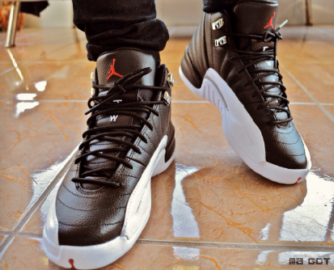
Tips and take-away messages
- Register your intellectual property rights. Unless you have your rights registered, you have almost no recourse in China;
- Be vigilant. Patrol trade fairs and surf various B2B and B2C websites (such as Alibaba and Taobao) on the lookout for infringing articles;
- When you identify infringement, enforce your rights. If you build a reputation for being litigious then companies will be less likely to infringe your rights in future. The resources required to achieve such a reputation very much depend on the extent of the infringement;
- Build your case carefully. Ensure that you are taking action against the right company in the right form.

Please include the attached by-line after the article:

The China IPR SME Helpdesk supports small and medium sized enterprises (SMEs) from European Union (EU) member states to protect and enforce their Intellectual Property Rights (IPR) in or relating to China, Hong Kong, Macao and Taiwan, through the provision of free information and services. The Helpdesk provides jargon-free, first-line, confidential advice on intellectual property and related issues, along with training events, materials and online resources. Individual SMEs and SME intermediaries can submit their IPR queries via email (question@china-iprhelpdesk.eu) and gain access to a panel of experts, in order to receive free and confidential first-line advice within 3 working days.
The China IPR SME Helpdesk is an initiative by the European Union
To learn more about the China IPR SME Helpdesk and any aspect of intellectual property rights in China, please visit our online portal at http://www.ipr-hub.eu/.

http://www.cnbc.com/id/43826546
http://www.bcg.com/documents/file81362.pdf
http://www.businessinsider.com/afp-michael-jordan-loses-china-trademark-suit-report-2015-7?IR=T
http://www.businessinsider.com/afp-michael-jordan-loses-china-trademark-suit-report-2015-7?IR=T
http://bit.ly/1KBYXwU

