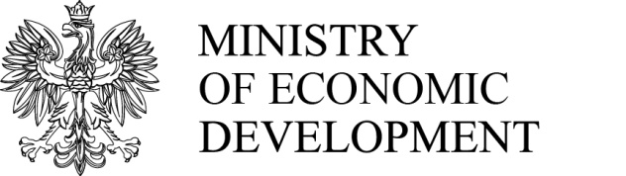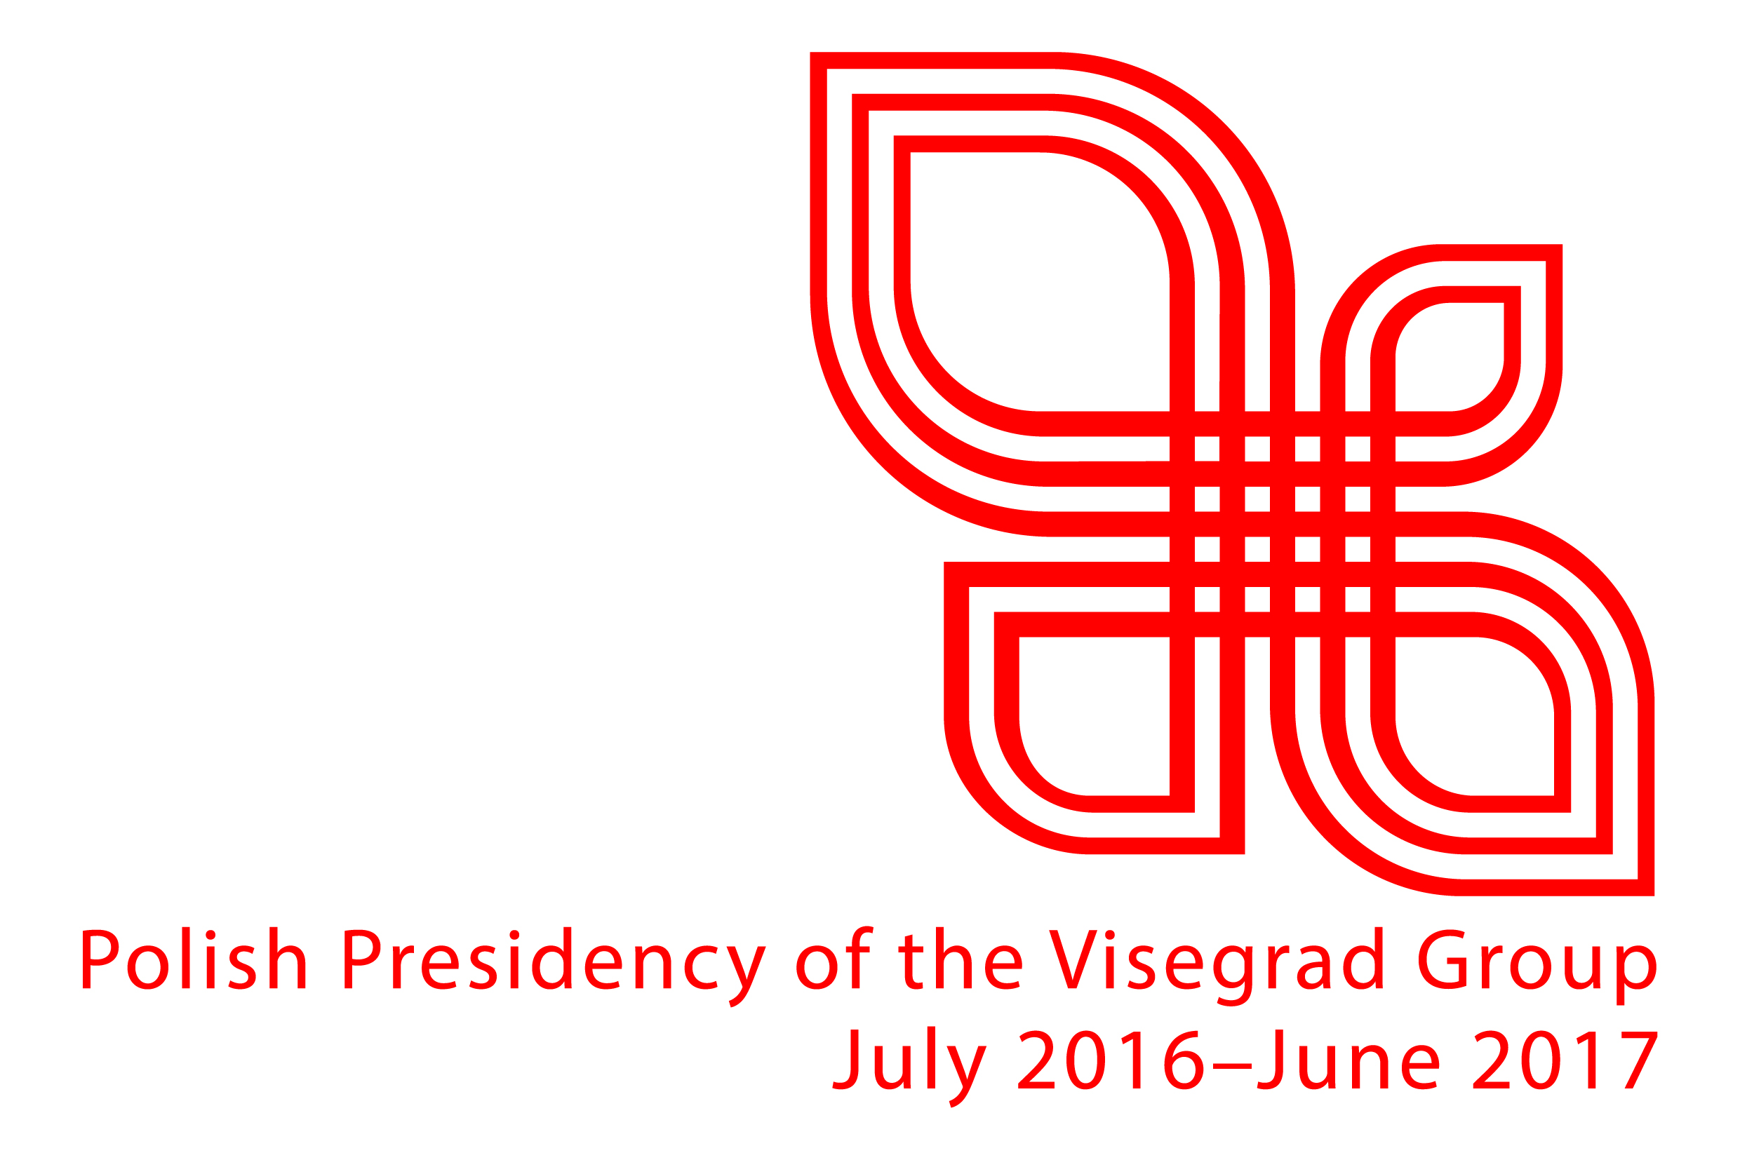
Registration Form
CLUSTER CONFERENCE*
Cluster policy and clusters’ cooperation of V4+4 countries
Organized by Ministry of Economic Development
30 June 2017, Warsaw, Plac Trzech Krzyży 3/5, Poland
To confirm your participation, please return the completed form to medsilesia@gapr.pl
by the 5th of June.
After 12th of June, patricipants of Matchmaking event will receive the list of participants allowing to schedule bilateral meetings.
Name of participation:
What kind of institution do you represent?
□ Cluster □ Administration □ Other
Name of institution and address:
Country:
Phone numer:
Email:
In which of the parallel sessions you wish take part? (please choose one session)
□ Session 1 □ Session 2 □ Session 3
□ Session 4 □ Session 5**
Descripe brifely activities:
Do you want to take part in matchmaking event?
□ Yes □ No
* Conference will be held in English.
** Session 5 is directed to policy makers, associations, other institutions interested in cluster policy.

