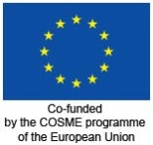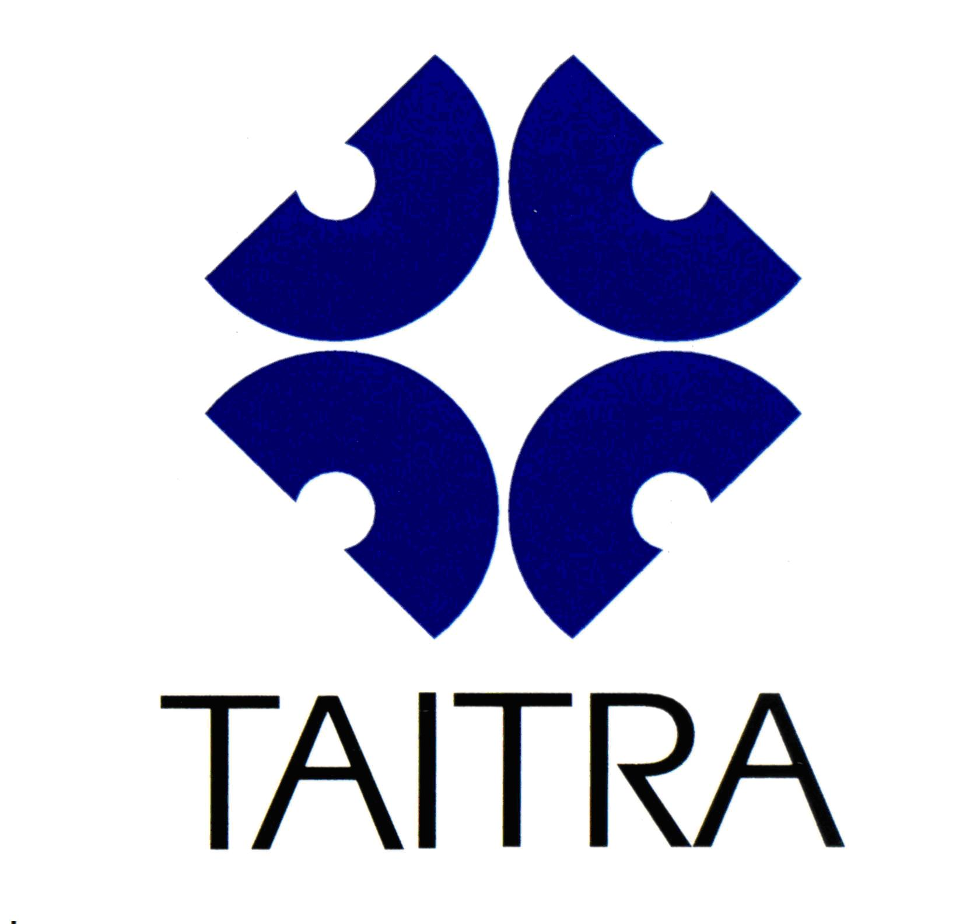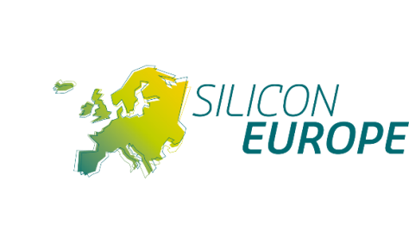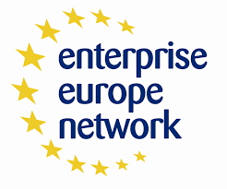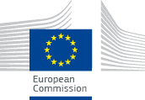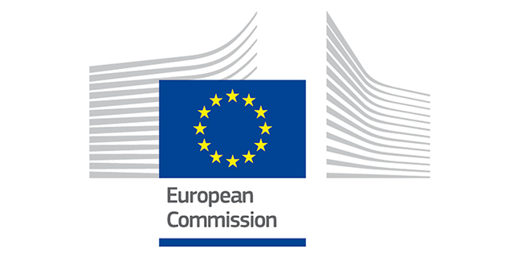



The European Innovation Week is organized at the occasion of the Industrial dialogue between the European Commission and Taiwan.

*Here is what you can expect:*

* **Promote your company** in Taiwan, an IoT hub for the rest of Asia
* **Attend** **COMPUTEX Taipei,** the biggest ICT Fair in Asia, attracting more than 1,700 international exhibitors covering the whole ICT supply chain from Consumer Electronics to IOT

cid:image001.jpg@01D16A2B.3E18DD90

* **Participate in** **B2B, B2C and C2C Matchmaking Events** bringing Taiwanese and European companies, clusters, institutes and agencies together
* **Attend** **Workshops** where you can present your digital technologies enabling innovative solutions for Smart Health, Smart Mobility or Smart Industries and learn about the latest developments in 5G and nanoelectronics.

Interested?

Visit <https://www.b2match.eu/EU-Taiwan2016> for more information about the **European Week** and to register!

**European Innovation Week Taiwan**

**May 30th – June 3rd**

*The European Week is a joint initiative of the European Commission in collaboration with Silicon Europe, the Enterprise Europe Network coordinated by TAITRA, the EU Chamber of commerce in Taiwan, the European Cluster Collaboration Platform and the Industrial Technology Research Institute (ITRI)*

*This event is especially designed for you!*

**Workshops, B2B and clusters matchmaking, EU Innovation Programs**

**Smart Health – Smart Mobility – Smart Industry – 5G – Nano electronics**